KV BSF JALALABAD
Holidays Homework
Class - X
Subject - English
- Write message of these poems --dust of snow ,fire and ice .
- Write moral education of the stories:-, A triumph of surgery.
- What is the central idea of the lesson: a letter to God.
- Write the aim of the lesson Nelson Mandela -long Walk to Freedom.
- Prepare your Editorial colum for a prestigious daily news paper. Word limit upto100.
- Write a debate against and favour "Woman empowerment in India"
- Prepare a Thesaurus of 100 words from your prescribed English book.
- Write and learn questions & answers of A triumph of surgery & A Letter to God
- Complete your portfolio file in all respects.

Subject – Social Science
- Make a project file on Consumer Awareness or any Social Issues, as given by CBSE
- Complete map work of class 10, as given by CBSE in classwork notebook
- Make a model on any topic from your book
- Make 20 MCQ from every chapter that has been completed.
Subject – Science
Physics (All the work should be done in Class work notebook.)
1. Draw cases of image formation by Spherical lenses and Spherical mirrors
2. Write a report on phenomenons of light ( 1 page for each phenomenon with picture)- Refraction, Reflection, Dispersion, Scattering of light
3. Write a brief report on following scientists - Sir CV Raman and Snell
4. Draw the well labelled and colourful diagram of Structure of Eye.
Chemistry
Activity–1 : Acid and Base
Collect Atleast 20 sample of different substance are used in day to day life and check whether they are acidic and basic by using turmeric powder and red onion as a natural indicator
To make the onion indicator cut one onion in to pieces and soaked in water for 24 hours boil and extract the onion juice.
.ex.lemon juice ,soap solution,toilet cleaner,curd,tomato juice,eno,saving cream sol. ,baking soda etc.
SAMPLES | Colour with turmeric | Colour with onion extract | Nature acidic/basic

Act.2 Name the acid and base (10 each )naturally occurring in plant and animals .

Act-3 Make a model of heron fountain & share the video of its working.

Act-4 Complete and Balance the following equations
1.CH₄+ O₂----------CO₂+H₂O
2.Al₂(SO₄)₃+BaCl₂------ a + b
3.KmnO₄ +H₂SO₄+ FeSO₄-------------MnSO₄+Fe₂(SO₄)₃+H₂O
4.C₂H₄+ O₂----------CO₂+H₂O
5.Sodium sulphate +Calsium Chloride------- a + b
.
Activity–5 solve the following work sheet and marks the questions which are not solved by you and discuss with your science teacher.

Open the zip file and practice :-

Activity 6:- Write the in text and exercise question answer in your note book
of chapter 1.

Act-7Explore the ideas to participate in inspire award, NCSC and Science Exhibition.

Biology
Week-1
Topic- Life process Sub topic- Nutrition in plant and animal
Reading- Read topic
Writing-Frame10very short questions or one word answer/questions from chapter
Diagram-practice diagram of a) Human digestive system ( b) Nutrition in Amoeba
Learning- Learn NCERT book questions of given topic and one line frame questions
Week -2
Topic-Life process Sub -topic: respiratory system.
Activity- Do activity to check the different taste by using tongue.
Reading - Read the topic thoroughly
Writing/ learning-1) frame 10 one word/ line answer question from given topic.
Activity-prepare list on different type of respiratory organ in different organisms
Drawing-practice/ Draw diagram of human respiratory organ
Week -3
Topic- Life process Sub topic- circulatory system
Reading-Read the topic
Writing :Frame 5 one line questions
Learning- learning NCERT questions of giveb topic and one line frame questions
Drawing-practice the diagram of human heart and double circulatory syste
Week 4
Topic - life process Sub-topic-Excretory system
Model- Draw well labelled diagram ofExcretory system
Reading: read topic
Writing /learning-frame five one line answer question and learn.
Week -5
Topic- life process
Reading: Read the chapter
Writing- Frame 10 one line and one cct base questions
Learning-Learn NCERT book questions and one line frame questions
Project- prepare project on artificial kidney

Subject - Hindi
1.निम्नलिखित विषयों पर 200 से 250 शब्दों में लेख लिखिए -
-आधुनिक भारतीय नारी -चैन जानता मोबाइल
-विज्ञापनों की अनोखी दुनिया -राजभाषा हिंदी
2.अपने क्षेत्र में फैली गंदगी के कारण उत्पन्न में डेंगू और मलेरिया जैसी भयंकर बीमारियों की रोकथाम हेतु स्वास्थ्य निरीक्षक को पत्र लिखिए।
3. नवभारत टाइम्स, नई दिल्ली के मुख्य संपादक को पत्र लिखिए जिसमें सड़क परिवहन के नियमों की उपेक्षा करने वालों के प्रति पुलिस के ढीले-ढाले रवैये पर चिंता प्रकट की गई हो ।
4.निम्नलिखित वाक्यों में प्रयुक्त पदों का परिचय लिखिए -
1.लंका के राजा रावण को राम ने बाण से मार दिया।
2.निर्धन मजदूर अनथक परिश्रम कर रहा है ।
3.देश का सर्वश्रेष्ठ खिलाड़ी कौन है ?
4.सरोवर में कमल-पुष्प खिल रहे हैं ।
5 अध्यापिका हिंदी पढ़ा रही है ।
6.नेताजी का चश्मा- पाठ का परिचय लिखकर प्रश्न-उत्तर करें ।
7.महात्मा सूरदास का परिचय लिखकर चारों पदों का भावार्थ लिखिए ।
8.बालगोबिन भगत - पाठ का परिचय लिखकर प्रश्न- उत्तर कीजिए।

Subject - Mathematics

Q.1. Find the HCF of 96 and 404 by the prime factorisation method. Hence, find their LCM.
Q.2. Find the HCF and LCM of 6, 72 and 120, using the prime factorisation method.
Q.3. Prove that √3 is irrational
Q. 4 . Show that 5 – √3 is irrational
Q.5. Find the zeroes of the quadratic polynomial X² + 7X + 10, and verify the relationship between the zeroes and the coefficients.
Q.6. Find the zeroes of the polynomial X² – 3 and verify the relationship between the zeroes and the coefficients.
Q.7. Find a quadratic polynomial, the sum and product of whose zeroes are – 3 and 2, respectively.
Q.8. Two rails are represented by the equations x + 2y – 4 = 0 and
2x + 4y – 12 = 0. Represent this situation geometrically.
( Activity )
Fill in the puzzle so that every rows across , every column down and every 3 by 3 box contain the numbers 1 to 9.

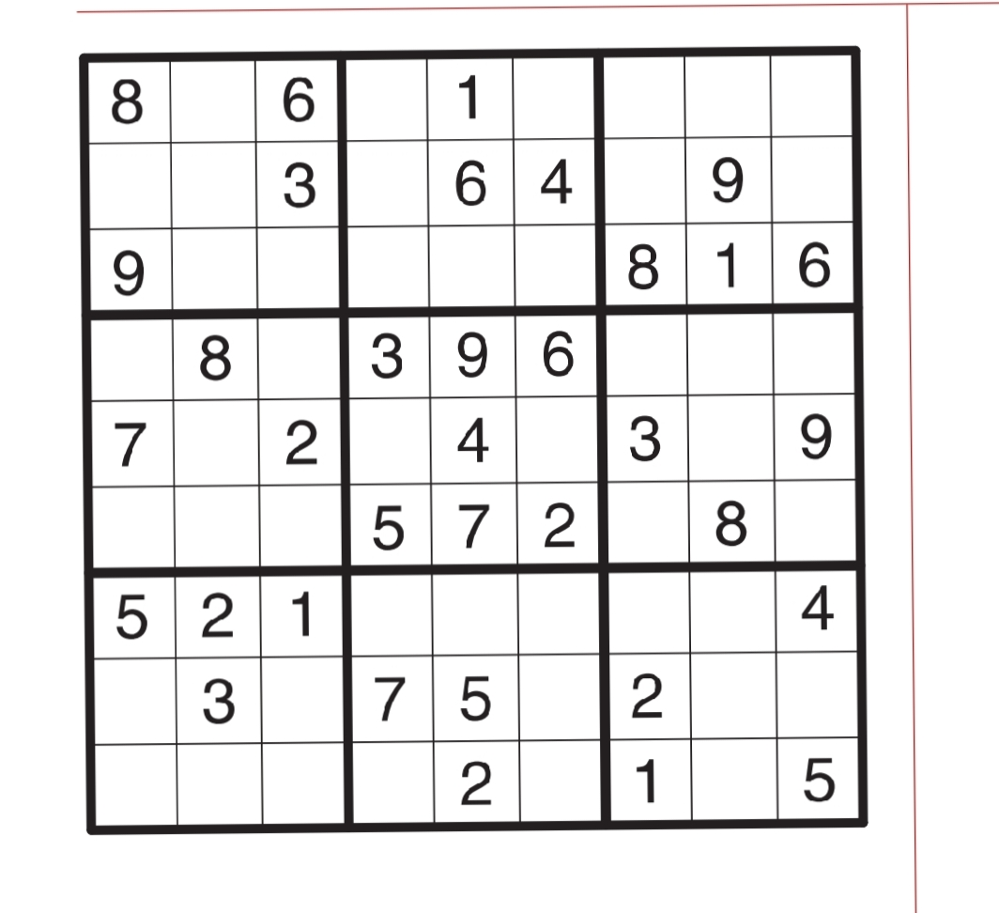

Subject – Computer
- Define communication
- Explain methods of communication (verbal, non-verbal and visual)
- Pros and cons of verbal and non-verbal communication
4. Complete all the exercise work of unit-1 (communication skill-II)
5. Make a chart by pasting pictures or by drawing with the help of internet on the topic of Artificial intelligence or make a model on the topic of Artificial intelligence

Subject – Work Experience
1. Book Binding Activity – Bind 1 book and 1 notebook.
2. Locate thermal power plant in political map of India
3. Locate thermal power plant in political map of India
4. Connect 3 bulb holders and 3 switches.

