KV BSF Jalalabad
Holidays Homework
Class VIII

Subject - English

Q1.Write moral of the story in your own words.
"How the camel got his Hump"
Q2.What lesson you have learnt from "The Best Christmas present in the world".
Q3.Write central idea of the poem"The Ant and the cricket".
Q 4.Write ten lines on the given topics:- Dream of my life.
My favourite book.
Q5.Read the English newspaper and find out 10 new verb also write one sentence on each.
Q6 Find 20 new words from your prescribed English book and write in dictionary form.
Q7 Solve the given CCT paper carefully to comprehend the text and develope your creative and critical ability.(sent separately)
Q8.Prepare innovative projects based on tenses and sentence formation.

Subject - Mathematics
Q.1. Multiply 6 / 13 by the reciprocal of – 7 / 16 .
Q.2. find the multiplicative inverse of the following :.
(I) – 13 / 19 (ii) – 1 / 5
Q.3. Write.
(i) The rational number that does not have a reciprocal.
(ii) The rational numbers that are equal to their reciprocals.
(iii) The rational number that is equal to its negative.
Q. 4 . Two numbers are in the ratio 5:3. If they differ by 18, what are the numbers?
Q.5. Find five rational numbers between :
2/3 and 4/5 .
Q.6. Three consecutive integers are such that when they are taken in increasing order and multiplied by 2, 3 and 4 respectively, they add up to 74. Find these numbers.
Q.7. solve the following equations and check your answer :
(I) 9X + 6 = 5 + 4X ( ii) 4z + 9 = 8 – 5z
Q.8. The ages of Rahul and Haroon are in the ratio 5:7. Four years later the sum of their ages will be 56 years. What are their present ages?
Q.9. number of boys and girls in a class are in the ratio 5 : 8 . The numbers of boys is 8 more than the number of girls . what is the total class strength .
Q.10. the ages of Ram and Shyam are in the ratio 3 : 5 . Five years later the sum of their ages will be 56 years . what are their present ages ?

Activity;- (A)

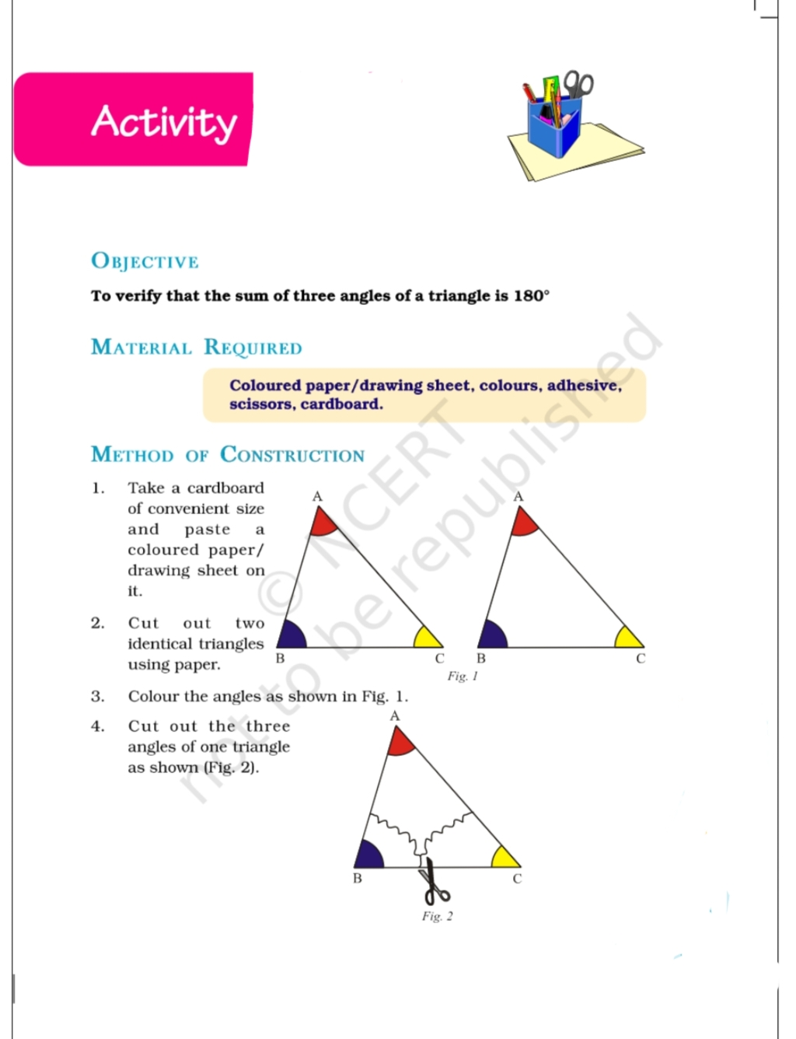
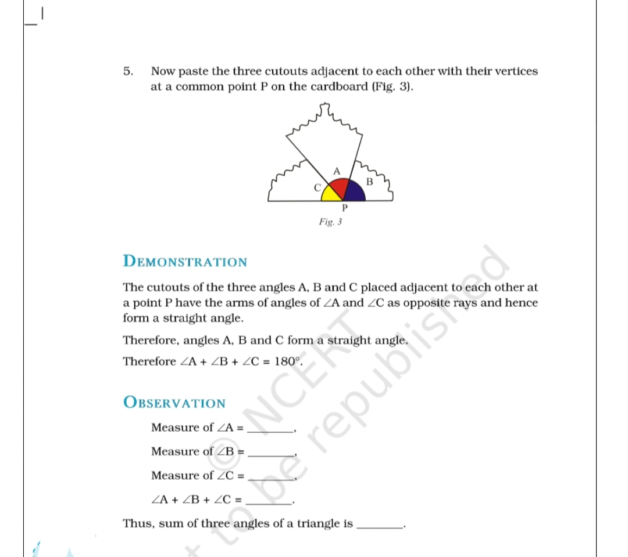

( Activity - B)
Fill in the puzzle so that every rows across , every column down and every 3 by 3 box contain the numbers 1 to 9.

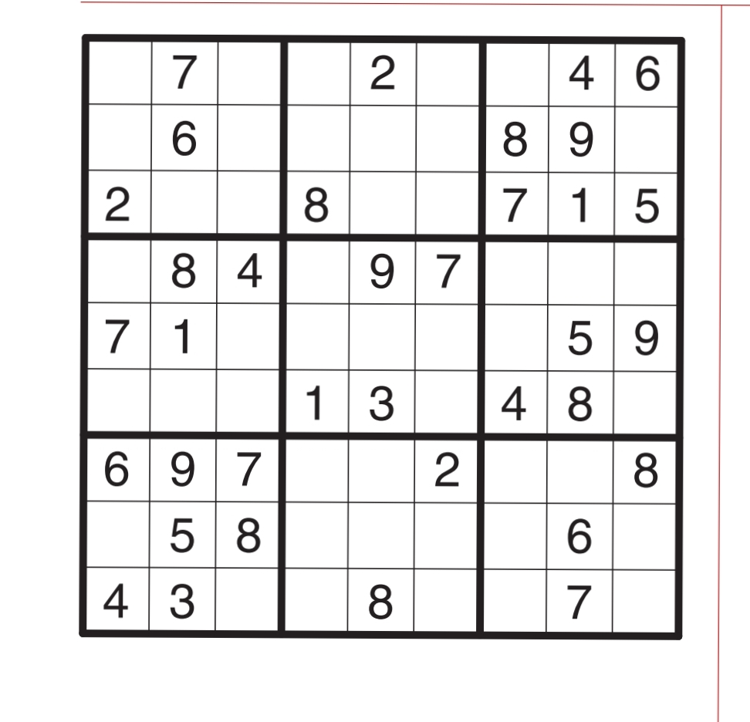
Activity.C. Online Puzzles
( Please open given below Link for Puzzle )
- https://in.ixl.com/math/class-viii/factors
- https://in.ixl.com/math/class-viii/divisibility-rules
- https://in.ixl.com/math/class-viii/prime-or-composite
- https://in.ixl.com/math/class-viii/prime-factorisation
- https://in.ixl.com/math/class-viii/highest-common-factor
- https://in.ixl.com/math/class-viii/lowest-common-multiple
- https://in.ixl.com/math/class-viii/hcf-and-lcm-word-problems
- https://in.ixl.com/math/class-viii/classify-numbers
- https://in.ixl.com/math/class-viii/integers-on-number-lines
- https://in.ixl.com/math/class-viii/integer-addition-and-subtraction-rules

Subject - Science
Activity–1 : Seeds
To study the effect of moisture on the germination of seeds.1

a) The students will take the gram seeds. Divide the seeds into three sets A, B and C.
b) Put the seeds of set A on the moist cotton.
c) Soak the seeds of Set B in the water overnight and then put on the moist cotton for seed germination.
d) Put the seeds of Set C in the boiling water for sometime then allow it to germinate on the moist cotton.
e) Make the video of your observations & share the video with your science teacher.
 | SET A | SET B | SET C
SEEDS
Activity–2: Irrigation
a) Collect the sample of sandy and clayey soil in tray.
b) Put the trays in the slanting positions.
c) Put the container on the other side of the tray (lower side) to collect the water.
d) Pour equal amount of water in both the trays.
e) Find out the water collected in the container.
f) Make the video of your observations & share the video with your science teacher.
SOIL SAMPLE | WATER COLLECTED IN BEAKER
SANDY SOIL
CLAYEY SOIL
Interpret your observations and correlate with the type of plants can be grown and the times of irrigation required.
Activity–3 : Preservatives
1. To know about the different methods of preservation.
a) Collect the wrappers of frozen and canned food items and milk.
b) Find about the preservatives present in these food items.
c) List the various preservatives and methods of their preservation.
1. List down the food items that are generally spoiled by the presence of bacteria. Taking any one example explain how it can be prevented.
Activity–4 : Character of different synthetic fibres from daily life
Find out the characteristics of different synthetic fibres used in daily life and categorise them according to their properties.
Procedure:
1. Collect atleast 10 different types of synthetic fibres used in household work in day to day life.
2. Find out their physical characteristics and type, and enlist them in tabular form.
3. On the basis of their properties categories them and try to find out the type of synthetic fibre.
4. Write their use in daily life.

Activity–5 Collect the pictures of various agricultural implements and paste then into your notebook. Write down their usage also.
Activity–6 list 5 disease caused by each of virus ,bacteria, protozoan & fungus.

Act.7 Prepare a report on discovery of vaccine and first antibiotic.
Act.8 Explore the ideas to participate in inspire award, NCSC and Science Exhibition.

Subject – Social Science
- Make a project on culture and festivals of Andhra Pradesh.
- Prepare a scrap book on Constitution of India.
- Make major centers of British rule on a political map of India.
- Read about any freedom fighter of India and make a chart along with pictures
- Prepare a chronology of major events of British Indian History
- Make a working model on any topic from your book
- Make 10 MCQ from every chapter that has been completed

Subject - Hindi
1. विशेषण की परिभाषा, भेद और उदाहरण लिखिए ।
2. सर्वनाम की परिभाषा, भेद और उदाहरण लिखिए।
3. कारक की परिभाषा, नाम और कारक चिन्ह लिखिए ।
4.वर्ण की परिभाषा लिखकर स्वर और व्यंजन अलग-अलग लिखिए ।
5. वर्णों के उच्चारण स्थानों का निर्देश कीजिए ।
6. 'ध्वनि' कविता लिखकर कविता का भावार्थ अपने शब्दों में लिखें । मुख्य प्रश्न और उत्तर भी करें ।
7. 'लाख की चूड़ियां' पाठ का सार अपने शब्दों में लिखें। सभी मुख्य प्रश्न और उत्तर करें ।
8. निम्नलिखित विषयों पर 150 से 200 शब्दों का अनुच्छेद लिखिए-
-कंप्यूटर युग
-मेरा गांव
-जल है तो कल है

9. ग्रीष्मावकाश में आपके विद्यालय के सभी छात्र शैक्षिक भ्रमण पर जाने वाले हैं ।किसी पर्वतीय स्थल की जानकारी, आवागमन के साधन और दर्शनीय स्थलों का उल्लेख करते हुए अपने विद्यालय के प्राचार्य को उसी स्थल पर टूर ले जाने के लिए प्रार्थना पत्र लिखिए।
10. प्रातः कालीन भ्रमण का महत्व बताते हुए अपने छोटे भाई/बहन को पत्र लिखिए।
11. 'भारत की खोज' पुस्तक पर आधारित प्रश्नों के उत्तर लिखिए।
1.अहमदनगर के किले में रहते हुए नेहरू जी को कलम उठाने पर विवश क्यों होना पड़ा?
2. चांद बीबी कौन थी ?
3. भारत के अतीत के बारे में जानने के लिए नेहरू जी ने किन चीजों का सहारा लिया?
4. अंग्रेजी शासन में किसानों की कौन-कौन सी समस्याएं थी ?
5. नेहरू जी ने किसानों को 'भारत माता की जय' का क्या अर्थ बताया?

Subject - Sanskrit
प्रिय बच्चों, संस्कृत गृह कार्य आप अलग नोटबुक में कीजिए।
प्रिया बच्चों, प्रतिदिन सुबह इस👇वीडियो को सुनकर श्लोक को याद कीजिए।

https://youtu.be/hTdZkPeIkhs

नीचे👇दिए गए लिंक पर जाकर प्रार्थना गीत याद कीजिए। (KVS PRAYER SONG)
https://youtu.be/TKal5HBTNrw

https://youtu.be/e2mFXfvt5X8

प्रिय बच्चों, इस लिंक👆🏻पर जाकर 1-20 तक गिनती संस्कृत में लिखकर याद कीजिए ।
https://youtu.be/NT7Qvi3f-zc
We shall overcome some day👆🏻.
https://youtu.be/ztgztmLllS0

संस्कृत गीत👆🏻 वीडियो सुनकर गाने का प्रयास कीजिए।

- संस्कृत छात्रप्रतिज्ञाया: प्रार्थनाया: च वाचनस्य पुनः पुनः अभ्यासं कुरुत ।
(संस्कृत छात्रप्रतिज्ञा और प्रार्थना को पुनः पुनः बोलने का अभ्यास करें और याद करें)
हिंदी में छात्र प्रतिज्ञा -
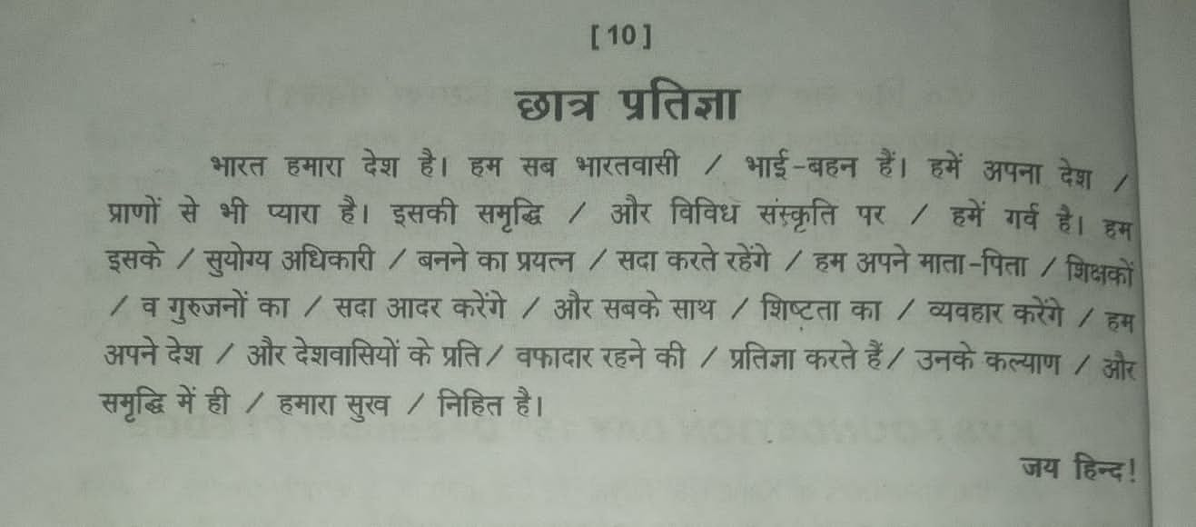
संस्कृत छात्र प्रतिज्ञा👇
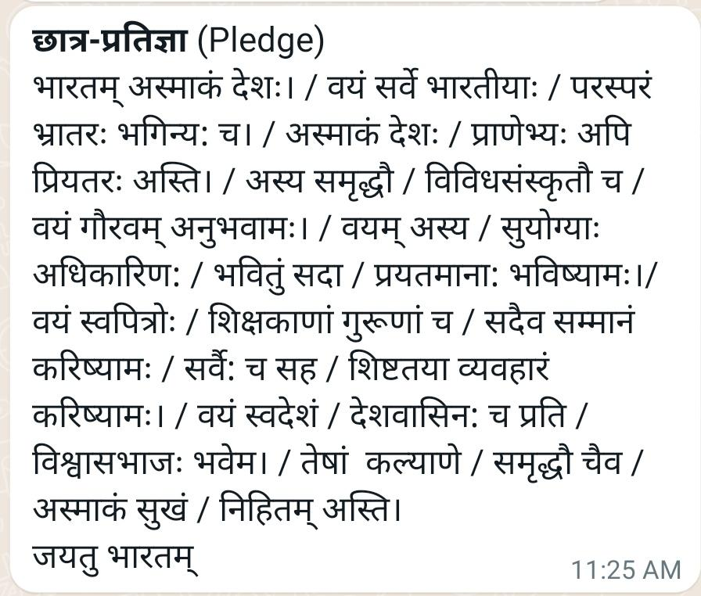
नोट - प्रिय विद्यार्थियों ऊपर लिखित गृहकार्य के आधार पर आपके " विषय संवर्धन क्रियाकलाप" (subject enrichment activity)के अंक लगाए जाएंगे।

- संस्कृत छात्रप्रतिज्ञाया: प्रार्थनाया: च वाचनस्य पुनः पुनः अभ्यासं कुरुत ।
(संस्कृत छात्रप्रतिज्ञा और प्रार्थना को पुनः पुनः बोलने का अभ्यास करें और याद करें)
- प्रथमपाठस्य श्लोकान् स्मृत्वा स्वअभ्यासपुस्तिकायां लिखत।
(प्रथम पाठ के श्लोकों को याद करके अपनी अभ्यास पुस्तिका में लिखिए)
- अस्मद् शब्दस्य रूपाणि लिखत ।
(अस्मद् शब्द के रूप लिखिए)
- खाद् धातुनां रूपाणि पञ्चलकारेषु च लिखत ।
(खाद् धातु के रूप पांचों लकारों में लिखिए)
- दश सरलसंस्कृत वाक्येषु स्वस्य परिचयं लिखत ।
( दश सरल संस्कृत वाक्यों में अपना परिचय लिखिए )
नोट:- प्रश्न संख्या 1-5 तक के गृहकार्य के आधार पर आपके लिखित गृहकार्य के अंक लगाए जाएंगे।

Subject – Computer
- Define algorithm
- Draw two examples of algorithm
- Define flow chart
- Draw two examples of flow chart
- Make a chart by pasting pictures or by drawing with the help of internet on the topic of ALGORITHM or FLOW CHART or any topic related with computer

Work Experience
1. Book Binding Activity- Bind 1 Book and 1 notebook
2. Paste newspaper cutting about electricity fault due to short circuit in WE notebook.
3. Connect 3 bulb holder with 3 switches.
4. Make a chart on short circuit by electricity.

