HOMEWORK FOR AUTUMN BREAK
CLASS- VI
CLASS-VI- ENGLISH

- REVISE ENTIRE SYLLABUS FOR TERM 1 EXAMINATION

- WRITE 50 FORMS OF VERB, THEIR PRESENT FORM, PAST FORM, PAST PARTICIPLE FORM AND FUTURE FORM ALSO. WRITE MEANINGS AS WELL

- WRITE ANY TWO STORIES THAT YOU LIKE THE MOST

- WRITE 20 DEGREES OF ADJECTIVES. FOR EXAMPLE:
GREAT GREATER GREATEST

- WRITE CHARACTER SKETCH OF THE OLD SHEPHERD AND TARO

शरद कालीन अवकाश गृह कार्य कक्षा - 6
विषय - हिंदी

निम्नलिखित पाठों के प्रश्न उत्तर एवं भाषा का विस्तार कार्य करें -

1 साथी हाथ बढ़ाना
2 ऐसे ऐसे
3 टिकट अलबम
4 झांसी की रानी

5 विशेषण की परिभाषा लिखकर उसके भेदों को लिखिएl
6.सर्वनाम की परिभाषा लिखकर उसके भेदों को उदाहरण सहित लिखिए
7 क्रिया की परिभाषा लिखकर सकर्मक और अकर्मक भेदों को स्पष्ट करें I

8 फीस माफ करवाने हेतु अपने विद्यालय के प्राचार्य को एक प्रार्थना पत्र लिखिए I
कक्षा- 6 विषय- संस्कृत
1.एक से आठ तक के पाठों के आधार पर आपने निम्न पाठों से क्या सीखा?,क्या मजेदार लगा? और क्या कठिन लगा? इसके बारे में अपनी शिक्षार्थी पत्रिका (learner's diary) में लिखें
2. MDP यानी (multidisciplinary project) बहुउद्देशीय परियोजना कार्य के अंतर्गत संस्कृत विषय के लिए प्रदत्त कार्य को पूरा करें।
3. पुष्प (नपुंसकलिंग शब्द) के शब्दरूप के आधार पर पुस्तक शब्द के शब्दरूप भी लिखो | (पृष्ठ- 90)
4.पाठ क्र. 8 सूक्तिस्तबक: के सभी श्लोकों को याद करो और अवकाश उपरांत अपनी कक्षा में सस्वर वाचन करें।
5. अपने गृहकार्य और कक्षाकार्य को पूर्ण करें और अवकाश पश्चात् जाँच करावें ।
Holidays homework
Class VI
Sub Science
Revision of chapters 1 to 8

Holidays homework
Class VI
Sub_ Social science
Ch _1 to 4 ( geo)
Ch_1 to 6 ( history)
Ch 1 to 4 (civics)
Revise these all chapters thoroughly.
Practice shared Google form links and live worksheet for preparation of
Term _1 Exam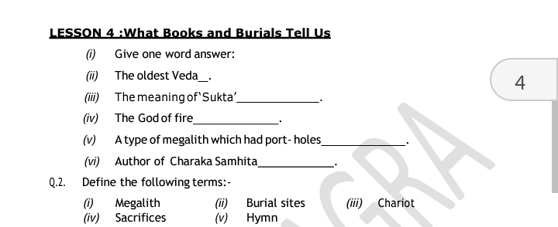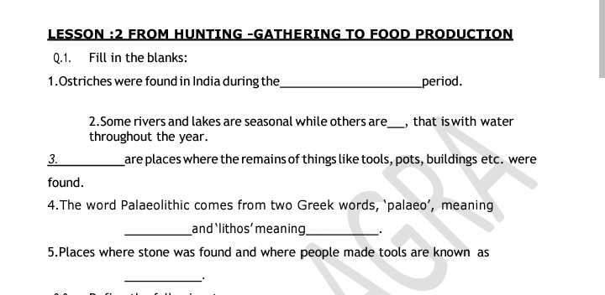
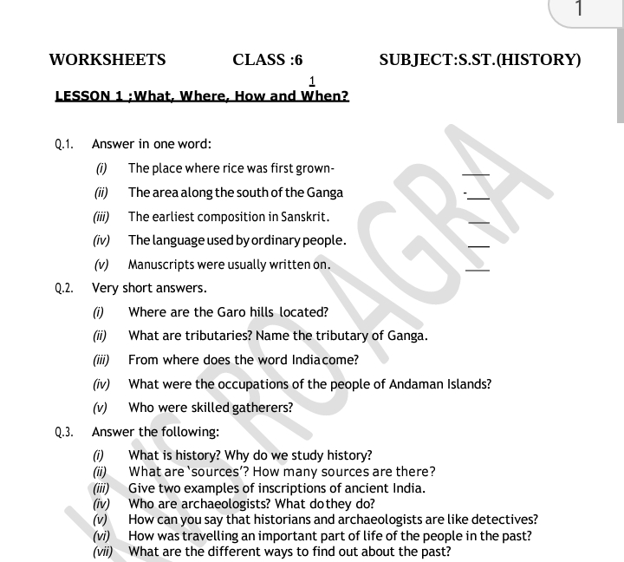

KENDRIYA VIDYALAYA B.S.F JALALABAD
Holiday Home work
( Your Holidays are from 09.10.2021 to 20.010.2021. )
Class :- 6
Subject – Mathematics
General Instruction: (I) All questions are compulsory.
Q.1. 1. A bus started its journey and reached different places with a speed of
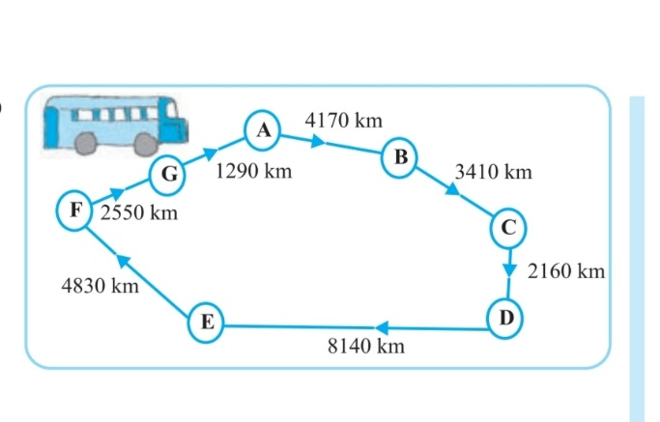
60 km/hour. The journey is shown on Given Diagram ..

(i) Find the total distance covered by the bus from A to D.
(ii) Find the total distance covered by the bus from D to G.
(iii) Find the total distance covered by the bus, if it starts from A
and returns back to A.
(iv) Can you find the difference of distances from C to D and D to E?
(v) Find out the time taken by the bus to Reach
( A) A to B (b) C to D ( C ) E to G (d) Total journey

Q.2. Renu purchases two bags of fertilizer of weight 75 kg and 69 kg . Find the maximum value of weight which can measure the weight of the fertilizer exact number of time .
Q.3. draw a rough sketch of a triangle ABC . Mark a point p in its interior and a point Q in its exterior . The point A in its exterior or in its interior .
Q.4. Draw any circle and mark
(a) its centre (b) a radius. (c) a diameter. (d) a sector. (e) a segment
(f) a point in its interior. (g) a point in its exterior (h) an arc

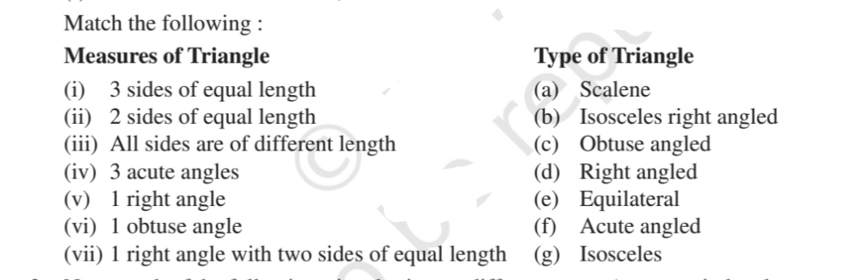
Q.5. math the following :-

KENDRIYA VIDYALAYA B.S.F JALALABAD
Holiday Home work
Class :- 7
Subject – Mathematics
General Instruction: (I) All questions are compulsory.

Q.1.

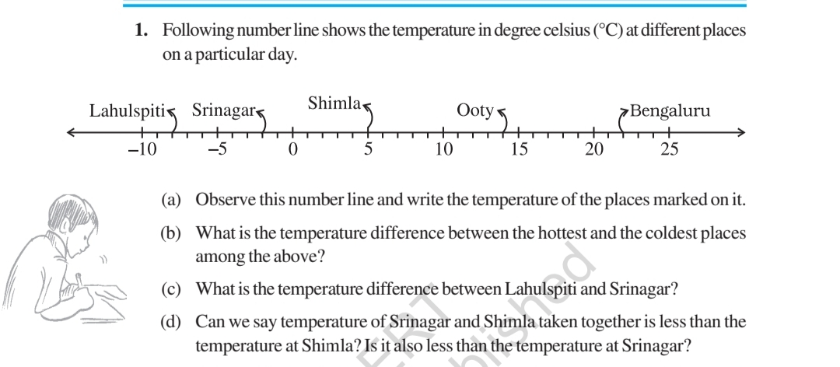

Q.2. . In a class test (+ 3) marks are given for every correct answer and (–2) marks are given for every incorrect answer and no marks for not attempting any question.
(i) Radhika scored 20 marks. If she has got 12 correct answers , how many questions has she attempted incorrectly?
(ii) Mohini scores –5 marks in this test, though she has got 7 correct answers. How many questions has she attempted incorrectly?

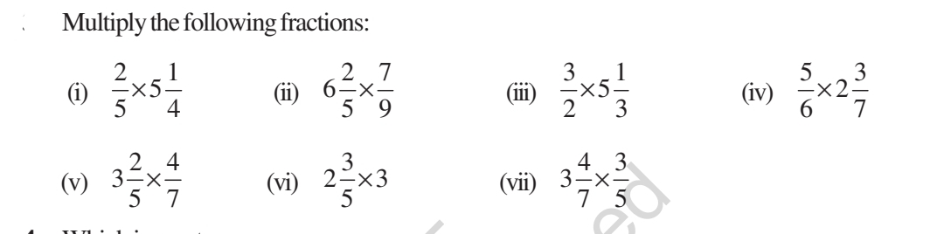
Q.3.

Q.4. Dinesh went from place A to place B and from there to place C. A is 7.5 km from B and B is 12.7 km from C. Ayub went from place A to place D and from there to place C. D is 9.3 km from A and C is 11.8 km from D. Who travelled more and by how much?
Q.5. Set up equations and solve them to find the unknown numbers in the following cases:
(a) Add 4 to eight times a number; you get 60.
(b) One-fifth of a number minus 4 gives 3.
(c) If I take three-fourths of a number and add 3 to it, I get 21.
(d) When I subtracted 11 from twice a number, the result was 15.
(e) Munna subtracts thrice the number of notebooks he has from 50, he finds the result to be 8.
(f) Ibenhal thinks of a number. If she adds 19 to it and divides the sum by 5, she will get 8.
(g) Anwar thinks of a number. If he takes away 7 from 5/2 of the number, the result is 23.

Holidays homework ( Sub_Social Science )

Class _7

Ch 1 to 5 ( geo)
Ch 1 to 6( history)
Ch 1 to 5 ( civics )

Revise these all chapters thoroughly for the preparation of Term _1 exam and after revision attempt online https://www.studiestoday.com/online-test/322/social-science.html for all chapters on the given –

शरद कालीन अवकाश गृह कार्य
कक्षा – 7 विषय – हिंदी

निम्नलिखित पाठों के प्रश्न उत्तर एवं भाषा का विस्तार कार्य करें –
1 शाम एक किसान
2 चिड़िया की बच्ची
3. अपूर्व अनुभव
4 रहीम के दोहे
5 क्रिया- विशेषण की परिभाषा लिखकर उसके भेदों को लिखिएl
6.सर्वनाम की परिभाषा लिखकर उसके भेदों को उदाहरण सहित लिखिए I
7 क्रिया की परिभाषा लिखकर सकर्मक और अकर्मक भेदों को स्पष्ट करें I

8 भाई की शादी में शामिल होने के लिए 2 दिन के अवकाश हेतु अपने विद्यालय के प्राचार्य को एक प्रार्थना पत्र लिखिए I

HOMEWORK FOR AUTUMN BREAK ( English )

CLASS-VII

- REVISE ENTIRE SYLLABUS FOR THE PREPARATION OF TERM 1 EXAMINATIONS
- WRITE 200 FORMS OF VERB, THEIR PRESENT FORM, PAST FORM, PAST PARTICIPLE FORM AND FUTURE FORM ALSO. WRITE MEANINGS AS WELL.
- WRITE SUMMARY OF THE ‘QUALITY’
- WRITE ANY TWO STORIES THAT YOU LIKE THE MOST.
- ,WRITE 50 DEGREES OF ADJECTIVES. FOR EXAMPLE:
GREAT GREATER GREATEST
- MAKE 4 TENSE CHARTS

कक्षा- 7 विषय- संस्कृत
एक से आठ तक के पाठों के आधार पर कि आपने निम्न पाठों से क्या सीखा?,क्या मजेदार लगा? और क्या कठिन लगा? इसके बारे में अपनी शिक्षार्थी पत्रिका (learner's diary) में लिखें ।
MDP यानी (multidisciplinary project) बहुउद्देशीय परियोजना कार्य के अंतर्गत संस्कृत विषय के लिए प्रदत्त कार्य को पूरा करें।
नदी (स्त्रीलिंग शब्द) के शब्दरूप के आधार पर लक्ष्मी शब्द के शब्दरूप भी लिखो । पृष्ठ- 95
पाठ क्र. 6 के सभी श्लोकों को याद करके अवकाश उपरांत अपनी कक्षा में सस्वर वाचन करें।
अपने गृहकार्य और कक्षाकार्य को पूर्ण करें और अवकाश पश्चात् जाँच करावें ।

CLASS VIII

Holidays homework
Sub _Social Science
Class _8
Ch 1 to 5 ( history)
Ch 1 to 4 ( geo )
Ch 1 to 5 ( civics)
Revise these all chapters thoroughly and attempt online tests for all chapters on given link
How, When and Where Class 8 MCQ From Trade to Territory Class 8 MCQ Questions
.Ruling the Countryside Class 8 MCQ Questions
Tribals, Dikus and the Vision of a Golden Age Class 8 MCQ Questions
When People Rebel 1857 and After Class 8 MCQ Questions.
Civics questions
The Indian Constitution Class 8 MCQ Questions
Understanding Secularism Class 8 MCQ Questions
Why Do We Need a Parliament Class 8 MCQ Questions
Understanding Laws Class 8 MCQ Questions
Judiciary Class 8 MCQ Questions
Geography Questions
Resources Class 8 MCQ Questions
Land, Soil, Water, Natural Vegetation and Wildlife Resources Class 8 MCQ Questions
Mineral and Power Resources Class 8 MCQ Questions
Agriculture Class 8 MCQ Questions
Click on all these links and separate test will open for particular topic, so attempt it everybody.
Thanks.

KENDRIYA VIDYALAYA B.S.F JALALABAD
Holiday Home work
Class :- 8
Subject – Mathematics
General Instruction: (I) All questions are compulsory.
Q.1. Fill in the blanks.
(i) Zero has ________ reciprocal.
(ii) The numbers ________ and ________ are their own reciprocals
(iii) The reciprocal of – 5 is ________.
(iv) Reciprocal of 1 / x , where x ≠ 0 is ________.
(v) The product of two rational numbers is always a _______.
(vi) The reciprocal of a positive rational number is ________.
Q.2. The ages of Rahul and Haroon are in the ratio 5:7. Four years later the sum of their ages will be 56 years. What are their present ages?
Q.3. A positive number is 5 times another number. If 21 is added to both the numbers, then one of the new numbers becomes twice the other new number. What are the numbers?
Q.4. Half of a herd of deer are grazing in the field and three fourths of the remaining are playing nearby. The rest 9 are drinking water from the pond. Find the number of deer in the herd.

Q.5. Construct the following quadrilaterals .
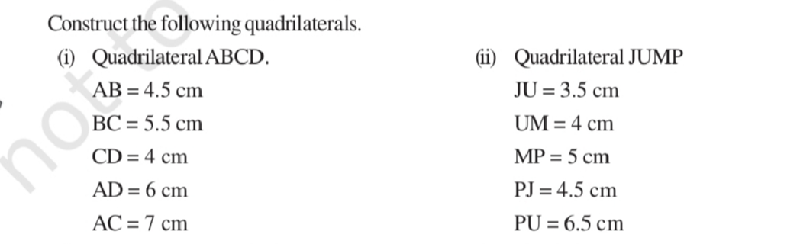

Q.6. Find the cube root of each of the following numbers by prime factorization method.
(i). 64 (ii) 512 (iii). 10648 (iv) 27000

Q.7. For each of the following numbers, find the smallest whole number by which it should be multiplied so as to get a perfect square number. Also find the square root of the square number so obtained.
(i) 252 (ii) 180 (iii) 1008 (iv) 2028

कक्षा- 8 विषय- संस्कृत
.एक से आठ तक के पाठों के आधार पर कि आपने निम्न पाठों से क्या सीखा?,क्या मजेदार लगा? और क्या कठिन लगा? इसके बारे में अपनी शिक्षार्थी पत्रिका (learner's diary) में लिखें ।
MDP यानी (multidisciplinary project) बहुउद्देशीय परियोजना कार्य के अंतर्गत संस्कृत विषय के लिए प्रदत्त कार्य को पूरा करें।
अस्मद् शब्द के शब्दरूप लिखकर के उसके आधार पर कोई पांच वाक्य संस्कृत में बनाएं| पृष्ठ- 123
पाठ-4 सदैव पुरतो निधेहि चरणम् पाठ को अच्छी तरह से याद करके अवकाश उपरांत अपनी कक्षा में सस्वर वाचन करें।
अपने गृहकार्य और कक्षाकार्य को पूर्ण करें और अवकाश पश्चात् जाँच करावें ।
English
1.Revise chapter 1-6 from Honeydew.
2. Revise chapters 1-6 from It so Happened.
3. Revise poems 1-6 from Honeydew.
4. Revise the Google form link shared in group and write in your notebook.
5. Bring an article for School magazine. It should be in Times New Roman. Font size should be 12
Science Holidays Homework:
Do Revision for Half yearly Exam.
Hindi
Do Revision for Half yearly exam.

CLASS IX

शरदकालीन अवकाश का गृहकार्य
सत्र -2021-22
कक्षा- 9 विषय - हिंदी
1.उपसर्ग -20
2.प्रत्यय-20
3.वाक्य
4.अलंकार
5.समास
6.एक कवि की जीवनी।
7.एक लेखक की जीवनी।
8. कबीर,ललद्यद एवं रसखान का परिचय।

HOMEWORK FOR AUTUMN BREAK
CLASS-IX

REVISE ENTIRE SYLLABUS FOR THE PREPARATION OF TERM 1 EXAMINATIONS
WRITE 300 FORMS OF VERB, THEIR PRESENT FORM, PAST FORM, PAST PARTICIPLE FORM AND FUTURE FORM ALSO. WRITE MEANINGS AS WELL.
WRITE SUMMARY OF THE ‘ADVENTURES OF TOTO’
WRITE ANY TWO STORIES THAT YOU LIKE THE MOST.
WRITE 50 DEGREES OF ADJECTIVES. FOR EXAMPLE:
GREAT GREATER GREATEST
WRITE CHARACTER SKETCH ‘ALBERT EINSTEIN’.
MAKE 6 TENSE CHARTS.

Class - 9th science
Biology: 1.Revision of fundamental unit of life
2.Revision of tissue chapter
3. practice of MCQs and Case based study questions of both chapters.

Class IX subject Mathematics
5 Sample papers for term-1 exam to be done on fair notebook of TERM-1.
Complete Chapter 2 and Chapter 8 on TERM-2 fair notebook
Complete CCT questions on separate portion of fair notebooks of both terms.
After autumn break there will be pre-term test for preparation of Term-1 examination. So whole syllabus of Term-1 to revised along with MCQs.

Class IX subject Mathematics
5 Sample papers for term-1 exam to be done on fair notebook of TERM-1.
Complete Chapter 2 and Chapter 8 on TERM-2 fair notebook
Complete CCT questions on separate portion of fair notebooks of both terms.
After autumn break there will be pre-term test for preparation of Term-1 examination. So whole syllabus of Term-1 to revised along with MCQs

.
Holidays homework
Sub _Social science
Ch 1 & 2 Geo
Ch 1&2 civics
Ch 1 history
Revise these all chapters and attempt the above given tests for all chapters☝️

CLASS X

HOMEWORK FOR AUTUMN BREAK
CLASS-X
- REVISE ENTIRE SYLLABUS FOR THE PREPARATION OF TERM 1 EXAMINATIONS
- WRITE 200 FORMS OF VERB, THEIR PRESENT FORM, PAST FORM, PAST PARTICIPLE FORM AND FUTURE FORM ALSO. WRITE MEANINGS AS WELL.
- WRITE SUMMARY OF ‘THE HAPPY PRINCE’
- WRITE ANY TWO STORIES THAT YOU LIKE THE MOST.
- WRITE 50 DEGREES OF ADJECTIVES. FOR EXAMPLE:
GREAT GREATER GREATEST
- WRITE CHARACTER SKETCH OF ‘A P J ABDUL KALAM’.
- MAKE 8 TENSE CHARTS.

शरदकालीन अवकाश का गृहकार्य👇

1. वाच्य।
2. पद परिचय।
3. वाक्य रचना के आधार पर।
4. रस।
5. हिंदी के किसी एक कवि का जीवन परिचय।
6. हिंदी के किसी एक लेखक की जीवनी।
7. दो पत्र।
8. दो बैलों की कथा, सूरदास के पद, तुलसीदास की चौपाइयों को स्मरण करें।

Mathematics
KENDRIYA VIDYALAYA B.S.F JALALABAD
Holiday Home work
Class :- 10. Subject – Mathematics
General Instruction: (I) All questions are compulsory.

Q.1. Diagonals of a trapezium ABCD with AB || DC intersect each other at the point O. If AB = 2 CD, find the ratio of the areas of triangles AOB and COD.
Q.2. ABC is an isosceles triangle with AC = BC. If AB² = 2 AC² , prove that ABC is a right angle triangle .
Q.3. Find the values of y for which the distance between the points
P(2, – 3) and Q(10, y) is 10 units.

Q.4. Find a relation between x and y such that the point (x, y) is equidistant from the point (3, 6) and (– 3, 4) .
Q.5. Find the area of a rhombus if its vertices are (3, 0), (4, 5), (– 1, 4) and (– 2, – 1) taken in order. [Hint : Area of a rhombus = 1/2(product of its diagonals) ].
Q.6. . In ∆ PQR, right-angled at Q, PR + QR = 25 cm and PQ = 5 cm. Determine the values of sin P, cos P and tan P.

Q.7. prove that (sin A + cosec A)² + (cos A + sec A)² = 7 + tan² A + cot² A.
Q.8. The wheels of a car are of diameter 80 cm each. How many complete revolutions does
each wheel make in 10 minutes when the car is travelling at a speed of 66 km per hour?
Q.9. In a circle of radius 21 cm, an arc subtends an angle of 60° at the centre .
Find:
the length of the arc.
(ii) area of the sector formed by the arc
area of the segment formed by the corresponding chord .
Q.10. A chord of a circle of radius 12 cm subtends an angle of 120° at the centre. Find the area of the corresponding segment of the circle. (Use π = 3.14 and 3 = 1.73)

SST
Holidays homework
Sub_Social Science
Holidays homework for class 10 SST ,

History:-Chapter 1 The Nationalism in Europe
Geography:-Ch 1. Resources and development
Ch 2. Agriculture
Civics:- Ch 1. Power sharing
Ch 2. Federalism
Economics:-Ch 1. Development
Ch 2. Sectors of India economy.
Revise these all chapters for Term1

https://drive.google.com/file/d/13cpQZG1ZTRSf8dTIPp_HgRVw-0_yvQHj/view
solve these all questions given under this link for all chapters☝️

